**Project Name**

**[Sub Title]**

*Project Report*

*Submitted by*

**Name of Student**

**Reg. No.: AJC00MCA-000**

*In Partial fulfillment for the Award of the Degree of*

**INTEGRATED MASTER OF COMPUTER APPLICATIONS**

**(INMCA)**

**APJ ABDUL KALAM TECHNOLOGICAL UNIVERSITY**

**AMAL JYOTHI COLLEGE OF ENGINEERING AUTONOMOUS**

**KANJIRAPPALLY**

[Affiliated to APJ Abdul Kalam Technological University, Kerala. Approved by AICTE, Accredited by NAAC. Koovappally, Kanjirappally, Kottayam, Kerala – 686518]

# 2020-2025

## DEPARTMENT OF COMPUTER APPLICATIONS

### AMAL JYOTHI COLLEGE OF ENGINEERING AUTONOMOUS

**KANJIRAPPALLY**



**CERTIFICATE**

This is to certify that the Project report titled “**PROJECT NAME”** is the bona fide work of **STUDENT NAME (Regno: AJC00MCA-0000)** carried out in partial fulfillment of the requirements for the award of the **Degree of Integrated Master of Computer Applications** at **Amal Jyothi College of Engineering Autonomous, Kanjirappally,** Affiliated to **APJ Abdul Kalam Technological University.** The project was undertaken during the period from **January 01, 2025** to **April 23, 2025**.

**Guide Name Coordinator Name**

**Internal Guide Coordinator**

**Rev. Fr. Dr. Rubin Thottupurathu Jose External Examiner**

**Head of the Department**

**// CERTIFICATE ON PLAGIARISM CHECK**

**DECLARATION**

I hereby declare that the project report **“PROJECT NAME”** is a bona fide work done at **Amal Jyothi College of Engineering Autonomous, Kanjirappally**, Affiliated to **APJ Abdul Kalam Technological University**, towards the partial fulfilment of the requirements for the award of the **Integrated** **Master of Computer Applications (MCA)** during the period from **January 01, 2025** to **April 23, 2025**.

**Date: STUDENT NAME**

**KANJIRAPPALLY Reg: AJC00MCA-0000**

# ACKNOWLEDGEMENT

First and foremost, I thank God almighty for his eternal love and protection throughout the project. I take this opportunity to express my gratitude to all who helped me in completing this project successfully. It has been said that gratitude is the memory of the heart. I wish to express my sincere gratitude to our Director (Administration) **Rev. Fr. Dr. Roy Abraham Pazhayaparampil** and Principal **Dr. Lillykutty Jacob** for providing good faculty for guidance.

I owe a great depth of gratitude towards our Head of the Department **Rev.Fr.Dr. Rubin Thottupurathu Jose** for helping us. I extend my whole hearted thanks to the project coordinator **Coordinator Name** for her valuable suggestions and for overwhelming concern and guidance from the beginning to the end of the project. I would also express sincere gratitude to my guide **Guide Name** for his inspiration and helping hand.

I thank our beloved teachers for their cooperation and suggestions that helped me throughout the project. I express my thanks to all my friends and classmates for their interest, dedication, and encouragement shown towards the project. I convey my hearty thanks to my family for the moral support, suggestions, and encouragement to make this venture a success.

STUDENT NAME

# ABSTRACT

.

**CONTENT**

|  |  |  |  |  |
| --- | --- | --- | --- | --- |
| **SL. NO** | | **TOPIC** | **PAGE NO** | |
| **1** | | **INTRODUCTION** |  | |
| **1.1** | | **PROJECT OVERVIEW** |  | |
| **1.2** | | **PROJECT SPECIFICATION** |  | |
| **2** | | **SYSTEM STUDY** |  | |
| **2.1** | | **INTRODUCTION** |  | |
| **2.2** | | **EXISTING SYSTEM** |  | |
| **2.2.1** | | **DRAWBACKS OF EXISTING SYSTEM** |  | |
| **2.3** | | **PROPOSED SYSTEM** |  | |
| **2.3.1** | | **ADVANTAGES OF PROPOSED SYSTEM** |  | |
| **3** | | **REQUIREMENT ANALYSIS** |  | |
| **3.1** | | **FEASIBILITY STUDY** |  | |
| **3.1.1** | | **ECONOMICAL FEASIBILITY** |  | |
| **3.1.2** | | **TECHNICAL FEASIBILITY** |  | |
| **3.1.3** | | **BEHAVIORAL FEASIBILITY** |  | |
| **3.1.4** | | **FEASIBILITY STUDY QUESTIONNAIRE** |  | |
| **3.1.5** | | **GEOTAGGED PHOTOGRAPH** |  | |
| **3.2** | | **SYSTEM SPECIFICATION** |  | |
| **3.2.1** | | **HARDWARE SPECIFICATION** |  | |
| **3.2.2** | | **SOFTWARE SPECIFICATION** |  | |
| **3.3** | | **SOFTWARE DESCRIPTION** |  | |
| **3.3.1** | | **PHP** |  | |
| **3.3.2** | | **MYSQL** |  | |
| **4** | | **SYSTEM DESIGN** |  | |
| **4.1** | | **INTRODUCTION** |  | |
| **4.2** | | **UML DIAGRAM** |  | |
| **4.2.1** | | **USE CASE DIAGRAM** |  | |
| **4.2.2** | | **SEQUENCE DIAGRAM** |  | |
| **4.2.3** | | **STATE CHART DIAGRAM** |  | |
| **4.2.4** | | **ACTIVITY DIAGRAM** |  | |
| **4.2.5** | | **CLASS DIAGRAM** |  | |
| **4.2.6** | | **OBJECT DIAGRAM** |  | |
| **4.2.7** | | **COMPONENT DIAGRAM** |  | |
| **4.2.8** | | **DEPLOYMENT DIAGRAM** |  | |
| **4.2.9** | | **COLLABORATION DIAGRAM** |  | |
| **4.3** | | **USER INTERFACE DESIGN USING FIGMA** |  | |
| **4.4** | | **DATABASE DESIGN** |  | |
| **5** | | **SYSTEM TESTING** |  | |
| **5.1** | | **INTRODUCTION** |  | |
| **5.2** | | **TEST PLAN** |  | |
| **5.2.1** | **UNIT TESTING** | |  |
| **5.2.2** | **INTEGRATION TESTING** | |  |
| **5.2.3** | **VALIDATION TESTING** | |  |
| **5.2.4** | **USER ACCEPTANCE TESTING** | |  |
| **5.2.5** | **AUTOMATION TESTING** | |  |
| **5.2.6** | **SELENIUM TESTING** | |  |
| **6** | **IMPLEMENTATION** | |  |
| **6.1** | **INTRODUCTION** | |  |
| **6.2** | **IMPLEMENTATION PROCEDURE** | |  |
| **6.2.1** | **USER TRAINING** | |  |
| **6.2.2** | **TRAINING ON APPLICATION SOFTWARE** | |  |
| **6.2.3** | **SYSTEM MAINTENANCE** | |  |
| **6.2.4** | **HOSTING** | |  |
| **7** | **CONCLUSION & FUTURE SCOPE** | |  |
| **7.1** | **CONCLUSION** | |  |
| **7.2** | **FUTURE SCOPE** | |  |
| **8** | **BIBLIOGRAPHY** | |  |
| **9** | **APPENDIX** | |  |
| **9.1** | **SAMPLE CODE** | |  |
| **9.2** | **SCREEN SHOTS** | |  |
| **9.3** | **GIT LOG** | |  |
| **9.4** | **CERTIFICATES** | |  |

## List of Abbreviations

# CHAPTER 1

# INTRODUCTION

### PROJECT OVERVIEW

### PROJECT SPECIFICATION

# CHAPTER 2

# SYSTEM STUDY

# 

### INTRODUCTION

### EXISTING SYSTEM

### NATURAL SYSTEM STUDIED

### DESIGNED SYSTEM STUDIED

### 2.2.1 DRAWBACKS OF EXISTING SYSTEM

### PROPOSED SYSTEM

### 2.3.1 ADVANTAGES OF PROPOSED SYSTEM



# CHAPTER 3

# REQUIREMENT ANALYSIS

## FEASIBILITY STUDY

### Economical Feasibility

### Technical Feasibility

### Behavioral Feasibility

* + 1. **Feasibility Study Questionnaire**

**3.1.5 Geotagged Photograph**

## SYSTEM SPECIFICATION

### Hardware Specification

Processor -

RAM -

Hard disk -

### Software Specification

Front End -

Back End -

Database -

Client on PC - Windows 7 and above.

Technologies used - JS, HTML5, AJAX, J Query, PHP, CSS, List APIs, List ML Functionalities

## SOFTWARE DESCRIPTION

### Eg.PHP

### Eg. MySQL

# CHAPTER 4

# SYSTEM DESIGN

* 1. **INTRODUCTION**

## UML DIAGRAM

## USE CASE DIAGRAM

Explanation, Diagram

## 4.2.2 SEQUENCE DIAGRAM

Explanation, Diagram

## 4.2.3 State Chart Diagram

Explanation, Diagram

## 4.2.4Activity Diagram

Explanation, Diagram

## 4.2.5Class Diagram

Explanation, Diagram

## 4.2.6 Object Diagram

Explanation, Diagram

## 4.2.7Component Diagram

Explanation, Diagram

**4.2.8 Deployment Diagram**

Explanation, Diagram

**4.2.9 Collaboration Diagram**

Explanation, Diagram

## 4.3 USER INTERFACE DESIGN USING FIGMA

**Form Name: abcc**

Screenshot

**Form Name: abcc**

Screenshot

All Forms of Main Project (minimum 8)

## DATABASE DESIGN

## Explanation

### 4.4.1 Relational Database Management System (RDBMS)

Explanation

### 4.4.2 Normalization

### Explanation with example

### 4.4.3 Sanitization

**4.4.4 Indexing**

### 4.5 TABLE DESIGN

**1.Tbl_users_login**

Eg.Primary key: **loginid**

Eg.Foreign key: **loginid** references table **Tbl_users_login**

|  |  |  |  |  |
| --- | --- | --- | --- | --- |
| **No:** | **Field name** | **Datatype (Size)** | **Key Constraints** | **Description of the field** |
|  |  |  |  |  |
|  |  |  |  |  |
|  |  |  |  |  |
|  |  |  |  |  |

**##All tables**

# CHAPTER 5

# SYSTEM TESTING

* 1. **INTRODUCTION**

Explanation

## TEST PLAN

Explanation

### Unit Testing

explanation

### Integration Testing

Explanation

### Validation Testing or System Testing

Explanation

### Output Testing or User Acceptance Testing

explanation.

* + 1. **Automation Testing**

explanation.

* + 1. **Selenium Testing**

explanation.

**Example:**

**Test Case 1**

**Code**

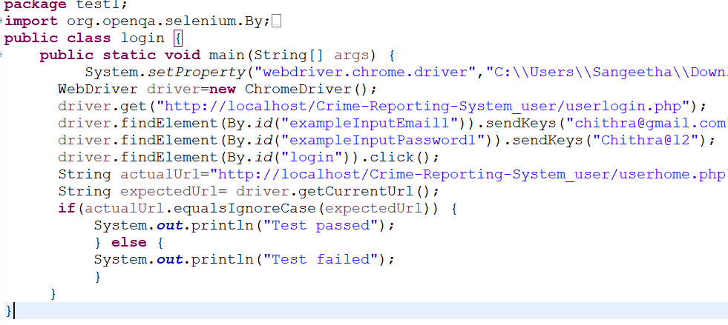

**Eg.Screenshot**

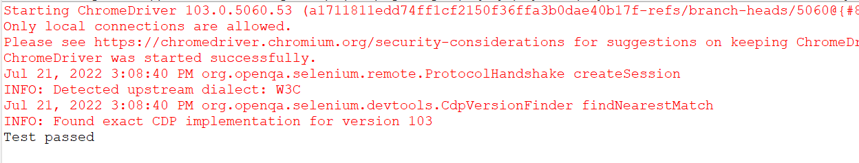

**Eg.Test Report**

|  |  |  |  |  |  |
| --- | --- | --- | --- | --- | --- |
| **Test Case 1** | | | | | |
| **Project Name:** | | | | | |
| **Login Test Case** | | | | | |
| **Test Case ID: Test_1** | | | **Test Designed By:** | | |
| **Test Priority(Low/Medium/High):** | | | **Test Designed Date:** | | |
| **Module Name**: | | | **Test Executed By :** | | |
| **Test Title :** | | | **Test Execution Date:** | | |
| **Description:** | | |  | | |
| **Pre-Condition :**User has valid username and password | | | | | |
| **Step** | **Test Step** | **Test Data** | **Expected Result** | **Actual Result** | **Status(Pass/**  **Fai l)** |
| 1 |  |  |  |  |  |
| 2 |  |  |  |  |  |
| 3 |  |  |
| 4 |  |  |
| 5 |  |  |  |  |  |
|  |  |  |  |  |  |
| 6 |  |  |
| 7 |  |  |  |  |  |
|  |  |  |  |  |
| **Post-Condition:** | | | | | |

**Test Case 2:**

**Code**

**Screenshot**

**Test report**

**Minimum 6 test cases of main project (1 Registration and login 5 different functionalities of main project, Can include Pass/Fail status)**

# CHAPTER 6

# IMPLEMENTATION

## INTRODUCTION

Explanation

## IMPLEMENTATION PROCEDURES

Explanation

### User Training

Explanation

### Training on the Application Software

Explanation

### System Maintenance

Explanation

* + 1. **Hosting**

Explanation

**Eg.000Webhost**

Explanation

**Procedure for hosting a website on 000Webhost:**

Step 1: explanation

Step 2: explanation

Step 3: explanation

.

.

**Hosted Website:**

**Hosted Link:** [**https://abc.000webhostapp.com**](https://abc.000webhostapp.com)

**Hosted Link QR Code**

**Screenshot**

# CHAPTER 7

# CONCLUSION AND FUTURE SCOPE

## CONCLUSION

## 

.

* 1. **FUTURE SCOPE**

.

# CHAPTER 8

# BIBLIOGRAPHY

### REFERENCES

* + - ..//books
    - ..
    - ..
    - ..
    - ...

### WEBSITES

* + - [..](http://www.w3schools.com/)
    - [..](http://www.jquery.com/)
    - [..](http://homepages.dcc.ufmg.br/%7Erodolfo/es-1-03/IEEE-Std-830-1998.pdf)
    - [..](http://www.agilemodeling.com/artifacts/useCaseDiagram.html)

# CHAPTER 9

# APPENDIX

## Sample Code

Main functionalities

## Screen Shots

## All screenshots

## Git Log

## 9.4 Certificates

## (Minimum 5)

Attach Plagiarism Report